

**Module 5 Sponsor Project**

**Group 3:**

Alex Stenli Parikh

Ansh Gaurav Kumar Dave

Sai Sachin Chandrasekar

Srikrishna Venkatesan

Tanya Fitkiriwala

Yash Mohan Moily

ALY 6080: Integrated Experiential Learning

Spring Quarter 2023

Northeastern University

Jay Qi

May 17, 2023

**Introduction**

The first article, "Integrated Forward and reverse supply chain: A tire case study," proposes a new model, the Integrated Forward and Reverse Supply Chain (IFRSC), that combines both the forward and reverse flows of materials and products to help businesses achieve cost-cutting, productivity enhancement, customer service improvement, and sustainability. The study provides a case study of a Malaysian tire company to demonstrate how this model can be implemented and the benefits it can provide.

The second article, "The impact of personal, market- and product-relevant factors on patronage behaviour in the automobile tire replacement market," focuses on the market for tire replacements and the factors that influence consumers' decisions to visit tire stores. The study concludes that trust and brand loyalty play a significant role in customers' decisions to visit a tire shop, and a tire dealer's ability to earn a customer's trust depends on both the service and the product they offer.

The third article, "Promises to match or beat the competition: Evidence from retail tire prices," looks at how price-matching guarantees affect retail tire prices. The study found that merchants who provide price-matching guarantees typically charge more than retailers who do not. Price-matching guarantees are more successful at boosting sales than price reductions, and this implies that retail stores can charge higher prices when offering price-matching guarantees since customers are ready to pay more for the guarantee's extra assurance.

**Key findings:**

1. The Integrated Forward and Reverse Supply Chain (IFRSC) architecture that has been developed can considerably lower costs and boost productivity in the tire business. The approach can save manufacturing costs by 5%, distribution costs by 7%, and procurement expenses by up to 2%.

2. Additionally, the IFRSC model may save lead times by up to 10% while increasing customer service levels by up to 5%.

3. The IFRSC model integrates forward and reverse flows of materials and products to optimize supply chains and enhance performance.

4. By encouraging the recycling and reuse of products and resources, the IFRSC model may also be utilized to lessen its negative effects on the environment.

5. By encouraging the recycling and reuse of resources and goods, the IFRSC model may also be utilized to lessen negative environmental effects.

6. The case study of a tire manufacturer in Malaysia shows how useful the IFRSC model is in real-world situations and argues that it may be used in other sectors with comparable supply chain plans. Trust and brand loyalty play a significant role in customers' decisions to visit a tire shop.

7. A tire dealer's ability to earn a customer's trust depends on both the service and the product they offer.

8. Trust and brand involvement are crucial components of relationship marketing theory.

9. Retailers who provide price-matching guarantees typically charge more than retailers who do not.

10. Price-matching guarantees are more successful at boosting sales than price reductions.

11. Retail stores can charge higher prices when offering price-matching guarantees since customers are ready to pay more for the guarantee's extra assurance.

**Summary**

Pedram, A., Nukman, Y., Udoncy, O. E., Mahat, A. B., Pedram, P., & Babalola, A. (2017,

February 1). Integrated forward and reverse supply chain: A tire case study. Waste Management. <https://www.sciencedirect.com/science/article/pii/S0956053X16303348>

The article explores the Integrated Forward and Reverse Supply Chain (IFRSC) model and its potential to improve the supply chain management of the tire industry. The study showcases a case study of a Malaysian tire company to demonstrate the advantages of the IFRSC model, which includes cost-cutting, productivity enhancement, customer service improvement, and sustainability. The IFRSC model combines both the forward and reverse flows of materials and products, providing a fresh approach to managing complex supply chain frameworks. The study also applies the IFRSC model to a real-world scenario in Iran, revealing its potential benefits in reducing costs and environmental impact while improving service levels and customer satisfaction. Overall, the article proposes the IFRSC model as a novel approach that could potentially help businesses better manage their supply chains, particularly in complex industries like the tire industry, to achieve their strategic goals.

While the article does not directly address how pricing for tires differs between car manufacturers and models, it highlights that tire manufacturers can optimize their supply chain management and potentially reduce costs, which could lead to lower tire prices. By implementing the IFRSC model, tire manufacturers can significantly reduce procurement, production, and distribution costs, which could translate to a decrease in tire prices. Additionally, the article emphasizes the potential benefits of the IFRSC model in reducing environmental impacts through recycling and reuse of materials and products, appealing to consumers who prioritize eco-friendliness. In conclusion, the IFRSC model offers a promising solution for tire manufacturers to enhance their supply chain management, reduce costs, and support sustainability, potentially leading to more affordable tires for consumers.

Mahama-Musah, F., Vanhaverbeke, L., & Gillet, A. (2020). The impact of personal, market-

and product-relevant factors on patronage behaviour in the automobile tire replacement market. Journal of Retailing and Consumer Services, 57, 102206. <https://www.sciencedirect.com/science/article/abs/pii/S0969698920301533>

The article goes over the significance of car tires to a vehicle's performance as well as the criteria manufacturers use to select tires. It largely focuses on the market for tire replacements and the elements, such as trust and brand loyalty, that influence consumers' decisions to visit tire stores. To acquire data and test theories regarding the variables impacting tire store patronage and consumers' willingness to travel to a tire shop, the authors performed a study combining focus group talks and a quantitative survey. The study concludes that trust and brand loyalty play a significant role in customers' decisions to visit a tire shop. The article also examines the relationship between consumers and retailers, where trust and brand involvement are seen as crucial components of relationship marketing theory. The study concludes that a tire dealer's ability to earn a customer's trust depends on both the service and the product they offer.

To conclude, From the perspective of our capstone project, this literature can help to analyze how customer behavior has an impact on the purchase of tires. Also, how managers are identifying the target customers which can lead to increased gross profit of the company. This will certainly impact the overall revenue of an organization.

Arbatskaya, M., Hviid, M. and Shaffer, G. (2000), "Promises to match or beat the competition:

Evidence from retail tire prices", Advances in Applied Microeconomics (Advances in Applied Microeconomics, Vol. 8), Emerald Group Publishing Limited, Bingley, pp. 123-138. <https://doi.org/10.1016/S0278-0984(99)08006-2>

The research article, "Promises to match or beat the competition: Evidence from retail tire prices" by David Byrne, Aleksandr Yankelevich, and Stephen J. Redding looks at how price-matching guarantees affect retail tire prices. Retail tire sales are one of the businesses that frequently offer price-matching assurances. These warranties give customers the assurance that they are getting the greatest deal possible by promising to match or beat the price of a competitor's product.

The impact of price-matching guarantees on retail tire prices is examined using data from online tire sellers. The authors found that merchants who provide price-matching guarantees typically charge more than retailers who do not. According to the study, price-matching guarantees are more successful at boosting sales than price reductions. This implies that retail stores can charge higher prices when offering price-matching guarantees since customers are ready to pay more for the guarantee's extra assurance. With these assurances and the subsequent price-matching guarantees, this article might assist VIP Tires and Service in choosing the best pricing strategy. This article may be useful in determining how to increase sales and what pricing strategy to employ considering all the discounts and promotional offers to maximise profit.

**Introduction**

With multiple businesses vying for clients, the tyre market is quite competitive. Tyre retailers must stay ahead of the curve in this cutthroat environment by discovering and putting into action ideas that can boost sales performance and customer satisfaction. As it offers insights into sales patterns, consumer behavior, and other aspects that might affect sales effectiveness, data analytics is becoming an increasingly crucial tool in this pursuit.

In this project, we'll investigate how data analytics strategies may boost tire store sales performance. We will specifically look at the ways in which sales data analysis, customer segmentation, A/B testing, sales forecasting, sales training and coaching, and regression analysis may be utilized to understand sales performance and develop sales improvement plans. We want to assist our sponsors in enhancing customer happiness and loyalty while also enhancing sales performance, income, and profitability.

**Analysis and Research Methods**

**What techniques have you used to explore the data you are working with? What did you find?**

* To perform any analysis, we have used Python as a scripting tool.
* The first step was to manually look at the datasets and understand all the variables.
* Then using Python, we performed the following:
  + **Descriptive statistics:** We initially looked at the size and shape of the dataset, the types of columns, and its data types

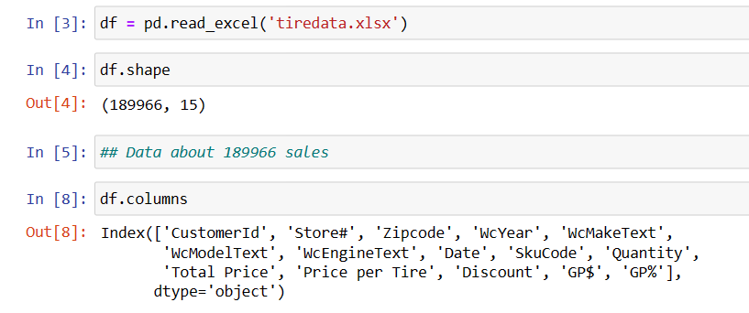

Fig 1. Descriptive Statistics

* + **Data visualization:** Then using data visualization, we tried to make more sense of the data

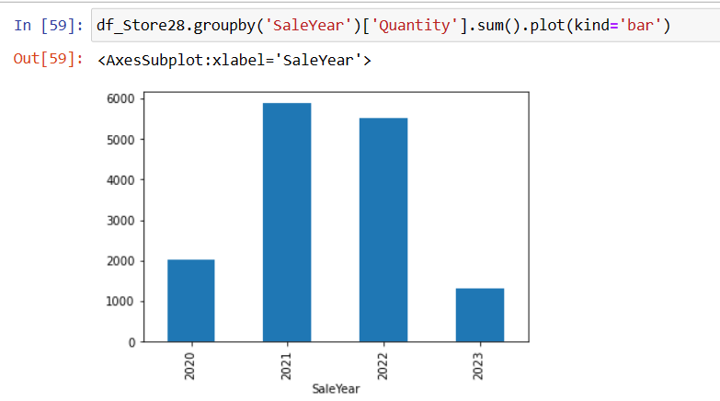

Fig 2. Quantity sold by the Year – store 28

For example, fig 2 displays that store 28 sold the maximum number of tires in 2021, followed by 2022.

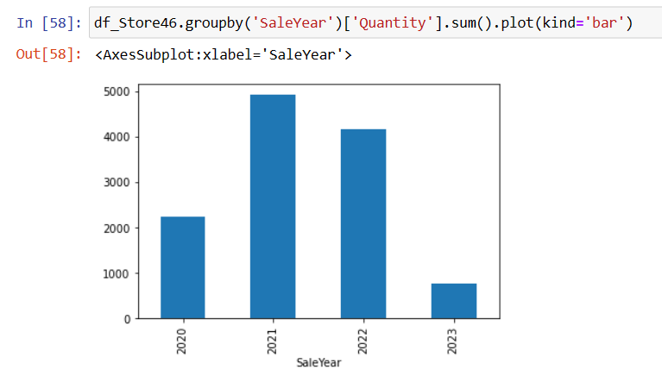

Fig 3. Quantity sold by the Year – store 46

Similarly, in fig 3, store 46 showed the same trend of maximum tired being sold in 2021.

If we compare the sales of all the stores, store 28 has the maximum sales with 14,741 quantities sold.

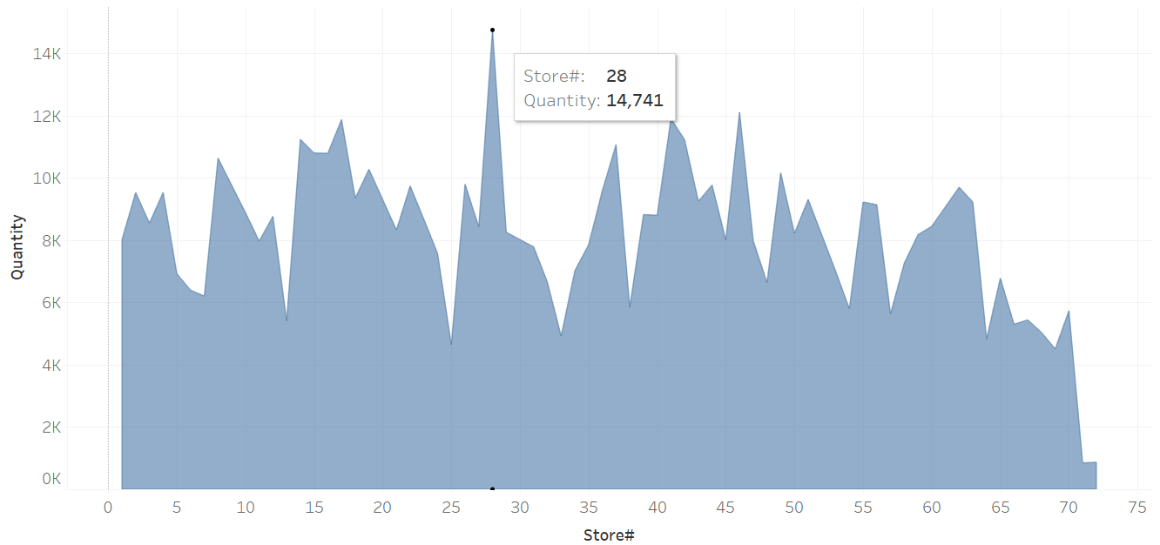

Fig 4. Sales comparison among stores

* + **Correlation analysis:** We performed the Pearson Correlation test on the university tires dataset to identify which variables are highly correlated

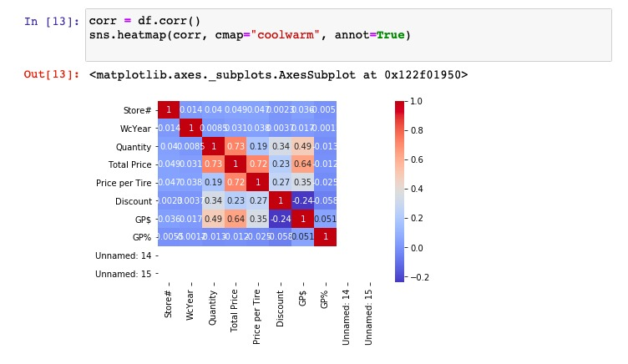

Fig 5. Correlation analysis

From the test in fig 5, we found the variables that are highly correlated and are presented below

1. Total Price and Price per Tyre

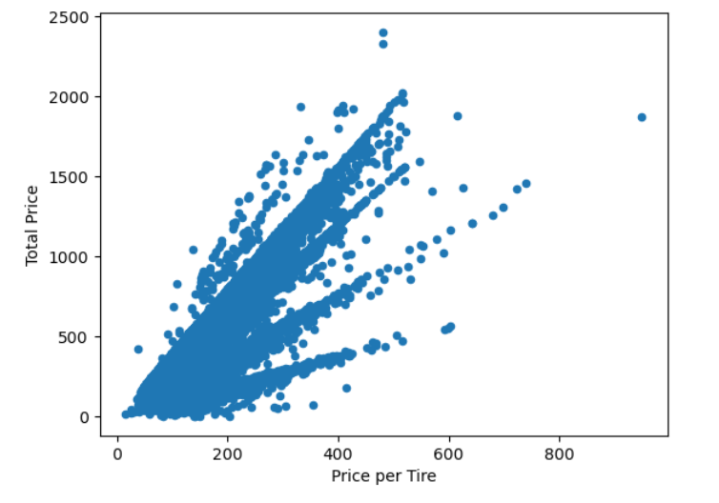

Fig 6. Correlation between Total Price and Price per Tire

As the correlation analysis suggested, there is a high positive correlation between the two variables.

1. Total Price and Quantity

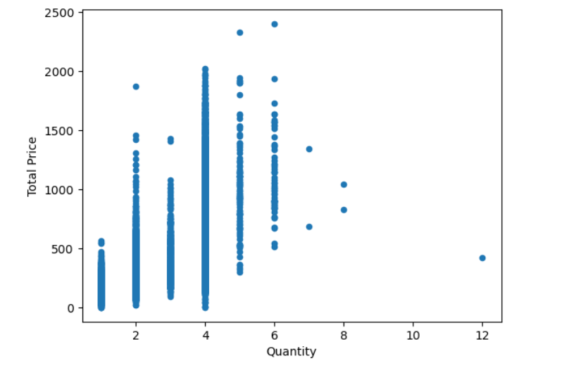

Fig 7. Correlation between Total Price and Quantity

Similarly, Total Price and Quantity are highly positively correlated

1. GP$ and Total Price

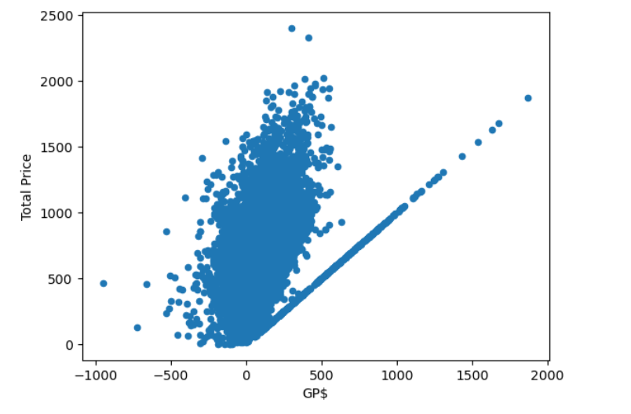

Fig 8. Correlation between GP$ and Price

GP$ and Total Price also display a positively high correlation

**Additional statistics:**

1. **Handling Null values:** In the sales dataset, we came across multiple columns that had null or missing values.

Fig 9. Missing or null values

For the variable WcMakeText, we have not excluded null values from the data as these values could be purchases without the owner having a car. We replace the value from null to ‘No wc’ as tires are not for any particular model.

For the price per tire and Quantities column, we have kept rows where values are greater than 0. Also, we have dropped the rows where quantities were null.

Hence, we have removed around 0.83% from our data.

1. **Treatment of Outliers:** The outliers are demonstrated with a box plot in figs 10, 11, and 12.

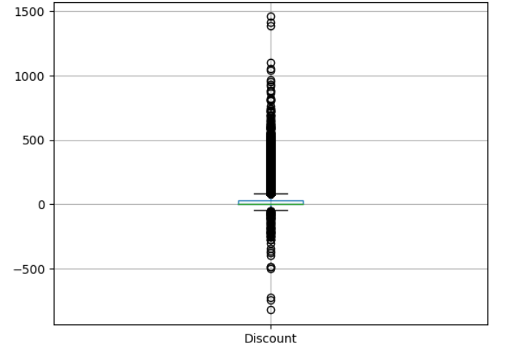

Fig 10. Discount box plot

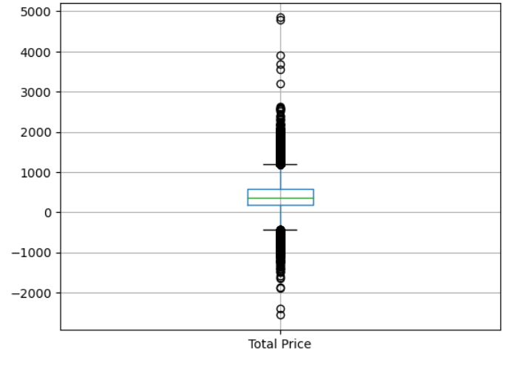

Fig 11. Total price box plot

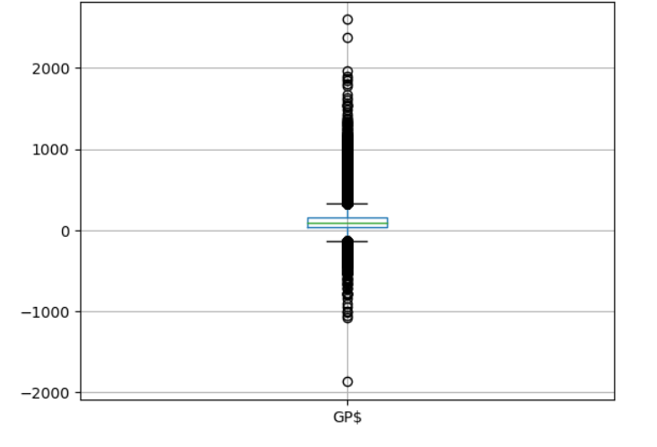

Fig 12. Gross Profit box plot

For our analysis, we have excluded the negative outliers from these three variables as these could be returned products. We have kept the positive outliers as a part of our analysis as these could be combined with other macroeconomic factors that could impact our predictive models.

1. **Profitable stores:** We have divided our analysis into two parts
2. **Profitable region:**

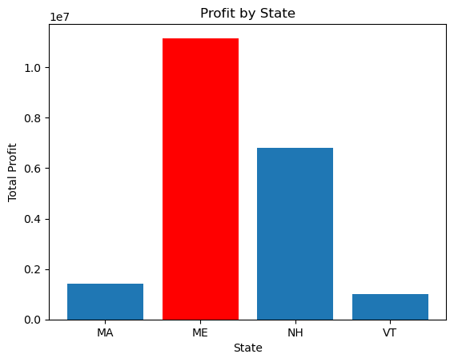

Fig 13. Profit by state

From Fig 13, we can see that the state of Maine has the highest profit in terms of sales.

1. **Profitable store:**

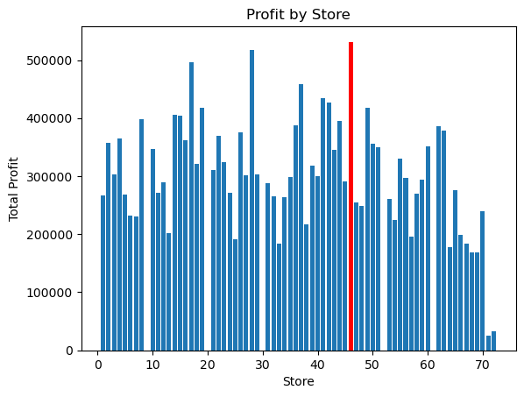

Fig 14. Profit by store number

Of the 72 stores, store 46 is the most profitable.

If we particularly observe the performance of store 46 from 2020 to 2023, 2020 and 2021, despite being covid periods, have had major number of sales.

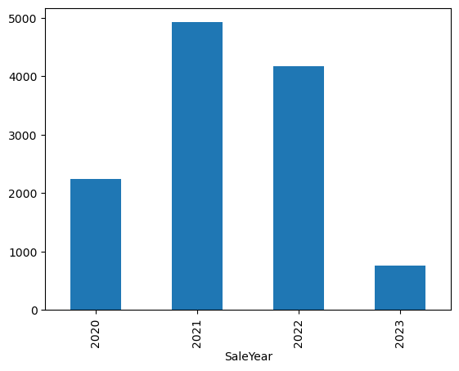

Fig 15. Sales of store 46

1. **Summary Statistics:**

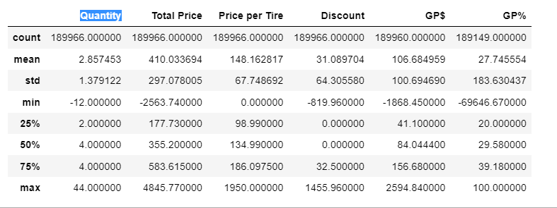

Fig 16. Descriptive statistics

**Quantity**: A standard deviation of 1.38, or around 2.86 on average, indicates some fluctuation in the quantities bought. The maximum amount is 44, whereas the lowest quantity of -12 denotes occurrences of returns or modifications.

**Total Price**: The typical total cost is $410.03, with a $297.08 standard variation. The prices vary from -$2,563.74 for the lowest price to $4,845.77 for the highest price (negative numbers signifying possible refunds or reductions).

**Price per Tire**: The standard deviation of the price per tire is $67.75, while the average price per tire is $148.16. The costs range from $0.00 (which can indicate free or reduced tires) to $1,950.00 (the highest).

**Discount**: The applied average discount is $31.09, with a $64.31 standard deviation. The markdowns are between -$819.96 (which denotes significant markdowns) to $1,455.96.

**Gross Profit (GP$):** With a standard deviation of $100.69, the average gross profit is $106.68. The figures vary from a negative $1,868.45 (which denotes losses) to a positive $2,594.84 (which denotes gains).

**Gross Profit Percentage (GP%):** With a large standard deviation of 183.63%, the average gross profit margin is 27.75%. The figures vary from -69,646.67% (which denotes considerable losses) to 100.00% (which denotes a complete profit margin).

1. **Correlation analysis:** To display the correlation among the numerical variables, we have created a correlation matrix, as can be seen in Fig 17.

The pairwise correlations between the variables are shown in the correlation table, along with the strength and direction of the linear associations. We can determine how strongly the variables are associated by looking at the correlation values. Although correlation does not imply causation, it is crucial to keep in mind that there may be a cause-and-effect link between the variables even when there is a substantial correlation.

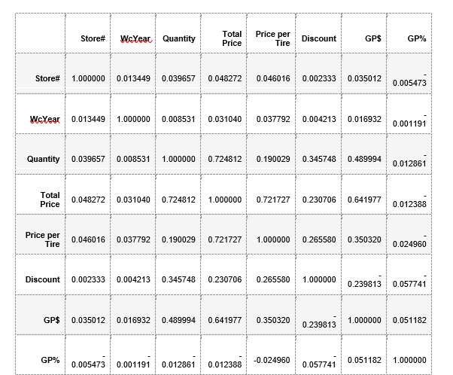

Fig 17. Correlation Matrix

* Store# shows a very slender positive correlation with the other variables, which points to a tenuous connection.
* Some factors and WcYear (Warranty Year) have a weakly positive correlation, suggesting a slender association.
* Quantity is moderately positively correlated with GP$, Price per Tire, Total Price, and Discount. This suggests that these factors tend to rise along with the amount.
* The relationship between Total Price, Quantity, Price per Tire, and GP$ is somewhat positive, demonstrating that higher prices are linked to bigger quantities and better gross profits.
* Higher tire prices are linked to higher total prices and gross profits since there is a somewhat positive association between Price per Tire and Total Price and GP$.
* Discount has a mild negative association with GP% but a weak positive correlation with Quantity, indicating that bigger discounts are linked to lower gross profit margins but larger sales volumes.
* The somewhat positive association between GP$ (Gross Profit) and Quantity, Total Price, and Price per Tire shows that bigger volumes and higher prices are linked to higher gross profits.
* A slender association between GP% (Gross Profit Percentage) and GP$ suggests a connection between gross profit percentage and gross profit.

1. **Tire Brand Performance:** In this step, we have showcased the performance of tire brands.

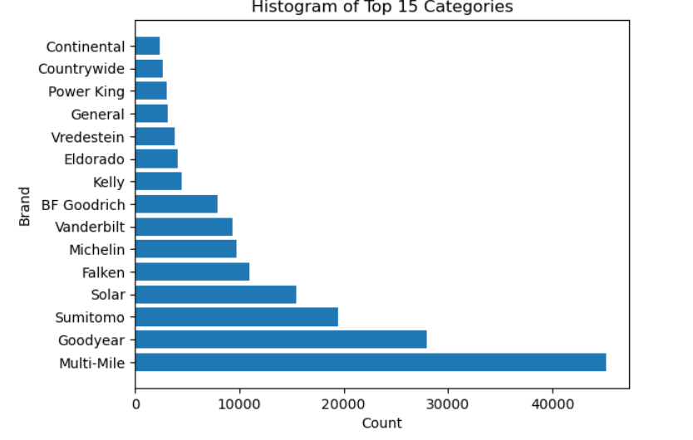

Fig 18. Top 15 tire brands by quantities sold

From Fig 18, we observe that the Multi-Mile and Goodyear are the most sold tire brands.

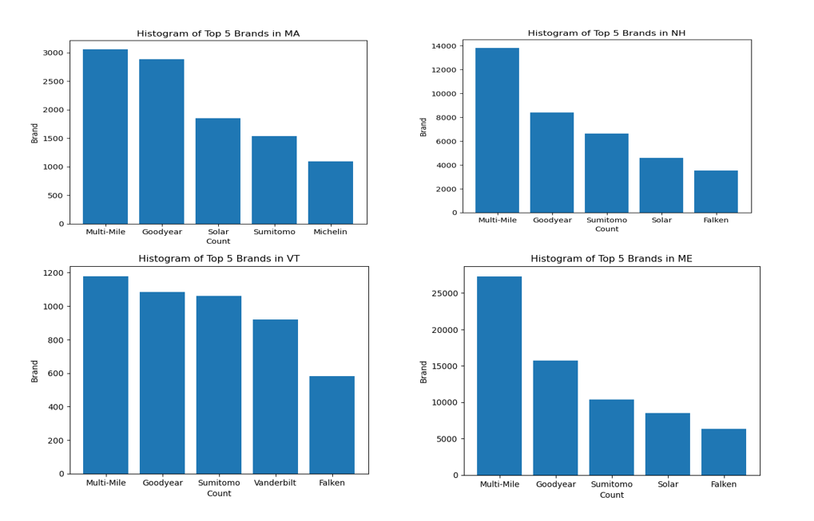

Fig 19. Region-wise sales of the top five tire brands

If we look at Fig 19, the region-wise breakup also presents the same result with Multi-Mile and Goodyear being the top two tire brands. In the state of Maine and Vermont, the difference in the number of tires sold by Multi-Mile and Goodyear is quite small. But this difference is quite huge in New Hampshire and Massachusetts.

**What techniques are you using to “tackle” your sponsor’s business question? How are you using those techniques?**

* To answer the business question, or solve the business question, we initiated the preliminary data analysis using descriptive and data visualization. This helped us in identifying which variables and files we would use moving forward.
* Our next steps are to do the following:
  + **Sales data analysis:** Using the historical sales data presented to us, we would analyze them to identify patterns and trends in sales by product, store, customer segments, and other factors.
  + **Regression analysis:** Regression analysis will be used to identify which factors are driving sales and to predict future sales based on those factors such as product features, store location, marketing spending, and customer demographics.

We can use various regression techniques, such as linear regression or logistic regression, depending on the nature of the data and the question being asked.

* **A/B testing:** Then we will use the A/B testing technique that involves testing different sales and marketing strategies on a small scale to measure their effectiveness before implementing them on a larger scale.
* **Sales forecasting:** Finally, we perform sales forecasting by building models to predict future sales based on historical data and external factors such as seasonality, economic indicators, and competition.

**Why are you using those techniques?**

* As per our understanding, these techniques can be later used to improve by gaining insights into sales performance, identifying areas of opportunity and potential risks, and developing strategies to improve sales. By using these techniques, we can make data-driven decisions that are based on evidence and insights rather than intuition or guesswork.
* Let’s say, we are trying to analyze which tire SKUs are selling and which are not, or maybe which brands of tires are selling and which are not, which can be answered using the techniques mentioned above. By using regression analysis, we can identify the factors that are driving sales and make predictions about future sales based on changes in those factors. Then, the sponsors can be informed to make a sound decision about their business.

**How will it be delivered to the sponsor?**

The results of the analysis and the insights gained would be delivered to the sponsors in a report or presentation format. The format and level of detail would depend on terms agreed with the sponsors, as well as the complexity of the analysis.

The report or presentation would typically include the following denotations:

* **Executive summary:** A brief summary of the key insights and recommendations.
* **Introduction:** A brief overview of the project, the data sets used, and the methods applied.
* **Analysis:** A detailed explanation of the methods used, including EDA, statistical analysis, and visualizations.
* **Key insights**: A summary of the key findings and insights gained from the analysis.
* **Recommendations:** Actionable based on the insights gained, including strategies to improve sales, optimize pricing, and enhance customer service.
* **Conclusion:** A summary of the main findings and recommendations, along with any limitations or caveats to the analysis.
* **Appendices:** Supporting materials such as data tables, statistical outputs, and charts.
* Additionally, the report or presentation would be accompanied by a question-and-answer session to address any questions or concerns the sponsors may have.

**Conclusion**

To conclude, we observed a variety of techniques including sales data analysis, A/B testing, sales forecasting, and regression analysis, through which sponsors can gain valuable insights into their sales performance and identify opportunities for improvement.

In this project, we have explored how these techniques can be used to improve sales performance in a tire store. We further aim to show how sales data analysis can identify which products are selling well and which ones are underperforming, while customer segmentation can help tailor sales and marketing strategies to specific customer segments. We also plan to demonstrate how A/B testing can be used to test different marketing strategies, and how regression analysis can identify the factors driving sales and make predictions about future sales.

Through our research methodology and results, we aim and hope that our sponsors can make

data-driven decisions and improve sales performance, and increase revenue and profitability.

**Introduction**

As per our sponsors, although profitability is one of the important aspects of any business, they already have that problem answered. Now we are rather focusing on the market potential of a particular brand for the VIP tires, and we are also taking all the external macro-economic factors into consideration which can act as a key driver to it.

So, we have changed our approach a bit going further into our project, our focus would be the brand and the external factors affecting it.

**Analysis and Research Methods: -**

Macro trends play a vital role in shaping the tire industry's landscape. Monitoring and adapting to these trends are crucial for tire manufacturers and stakeholders to remain competitive, meet changing consumer demands, comply with regulations, and drive sustainable growth.

We have considered some of the significant external factors which can certainly help us determine the market potential for specific brands going forward. We have considered CPI (consumer price index), Seasons of the tires that are being sold, Weather data of that location, employment data, and disposable income data.

We have used python programming language and some packages related to it for our further analysis.

|  |
| --- |
| **Tire Brands** |
| Multi-Mile 44988 |
| Non-Primary 42448 |
| Goodyear 27870 |
| Sumitomo 19396 |
| Solar 15395 |
| Falken 10905 |
| Michelin 9747 |
| Vanderbilt 9341 |
| BF Goodrich 7891 |
| Name: tire_company, dtype: int64 |

So, in table we can see the top 8 brands of the tires which we have categorised as primary tire

Brands that do not fall under the top 8 category are categorized as non-primary tire brands. As clearly shown in the table above there are 43,448 quantities of tires mentioned as non-primary.

Now let us take Multimile tire into consideration which is the most selling brand of the lot.

**Multimile tire**

|  |  |  |  |  |  |  |  |  |  |
| --- | --- | --- | --- | --- | --- | --- | --- | --- | --- |
| **Multimile tire** |  |  |  |  |  |  |  |  |  |
| **Stats** | **Quantity** | **SP/Tire** | **Discount** | **GP$** | **SaleYear** | **temp** | **dew** | **humidity** | **snow** |
| **count** | 44988 | 44988 | 44988 | 44988 | 44988 | 44988 | 44988 | 44988 | 44988 |
| **mean** | 2.762848 | 118.376302 | 28.245148 | 110.478294 | 2021.450387 | 48.506802 | 37.189551 | 68.228354 | 0.121881 |
| **std** | 1.285045 | 43.005026 | 54.146252 | 78.928694 | 0.807806 | 17.376816 | 18.606823 | 14.978452 | 0.846594 |
| **min** | 1 | 6.3 | 0 | -351.28 | 2020 | -6 | -27 | 25.6 | 0 |
| **25%** | 2 | 90.77 | 0 | 51.56 | 2021 | 34.7 | 23.4 | 57.6 | 0 |
| **50%** | 3 | 110.2 | 0 | 88.635 | 2021 | 48.6 | 36.5 | 68.5 | 0 |
| **75%** | 4 | 140.75 | 29.33 | 153.925 | 2022 | 63.3 | 53 | 79.8 | 0 |
| **max** | 16 | 382.78 | 672 | 755.7 | 2023 | 88.8 | 71.9 | 99.7 | 19.7 |

On average, customers purchase around 2.76 tires per transaction, and the average selling price per tire is $118.38. There is also an average discount of $28.25 per tire, which highlights the effectiveness of promotional activities. The dataset further reveals that the average gross profit per transaction is $110.48.

Mean temperature for this tire purchase was 48 degrees. And humidity of 68.22.

**Goodyear Tire**

|  |  |  |  |  |  |  |  |  |  |
| --- | --- | --- | --- | --- | --- | --- | --- | --- | --- |
| Goodyear tire |  |  |  |  |  |  |  |  |  |
| **Stats** | **Quantity** | **SP/Tire** | **Discount** | **GP$** | **SaleYear** | **temp** | **dew** | **humidity** | **snow** |
| **count** | 27870 | 27870 | 27870 | 27870 | 27870 | 27870 | 27870 | 27870 | 27870 |
| **mean** | 3.128561 | 196.988381 | 62.555969 | 100.222617 | 2021.427557 | 46.814123 | 36.06136 | 69.234385 | 0.155795 |
| **std** | 1.252424 | 61.628125 | 96.252854 | 100.371142 | 0.856097 | 17.319038 | 18.200828 | 14.658772 | 1.021596 |
| **min** | 1 | 1 | 0 | -724.16 | 2020 | -6 | -27 | 25.6 | 0 |
| **25%** | 2 | 154 | 0 | 30.8325 | 2021 | 33.2 | 22.9 | 58.6 | 0 |
| **50%** | 4 | 189.56 | 0 | 74.78 | 2021 | 45.9 | 34.6 | 69.3 | 0 |
| **75%** | 4 | 230.81 | 108.89 | 169.71 | 2022 | 61.7 | 51.5 | 80.6 | 0 |
| **max** | 12 | 672.97 | 1049.68 | 1364.64 | 2023 | 88.8 | 71.9 | 99.7 | 19.7 |

On average, customers purchase around 3.13 tires per transaction, and the average selling price per tire is $196.99. There is also an average discount of $62.56 per tire, indicating the presence of promotional activities. The dataset reveals that the average gross profit per transaction is $100.22. Comparing it to the Multimile Tire dataset, Goodyear tires have a higher average selling price and discount, indicating potentially higher-end products or different market positioning.

The mean Profit by selling these tires is 100 dollars. The median profit is 74 dollars. Hence, though higher prices but profit is more with multi-mile tires.

Mean temperature for sales of goodyear is 46 degrees, dew of 36 and humidity of 69.

**Sumitomo Tire**

|  |  |  |  |  |  |  |  |  |  |
| --- | --- | --- | --- | --- | --- | --- | --- | --- | --- |
| **Sumitomo Tire** |  |  |  |  |  |  |  |  |  |
| **Stats** | **Quantity** | **SP/Tire** | **Discount** | **GP$** | **SaleYear** | **temp** | **dew** | **humidity** | **snow** |
| **count** | 19396 | 19396 | 19396 | 19396 | 19396 | 19396 | 19396 | 19396 | 19396 |
| **mean** | 3.118478 | 135.191023 | 36.514822 | 126.081763 | 2021.213859 | 45.483651 | 34.781192 | 69.248871 | 0.107115 |
| **std** | 1.266779 | 48.118809 | 65.22902 | 86.099903 | 0.87251 | 17.074176 | 17.960986 | 14.809546 | 0.709457 |
| **min** | 1 | 28 | 0 | -274.08 | 2020 | -6 | -27 | 25.6 | 0 |
| **25%** | 2 | 101.99 | 0 | 61.1325 | 2021 | 32.5 | 21.275 | 58.6 | 0 |
| **50%** | 4 | 125.3 | 0 | 106.44 | 2021 | 44 | 33.6 | 69.2 | 0 |
| **75%** | 4 | 164.545 | 40 | 175.56 | 2022 | 59.3 | 49 | 80.7 | 0 |
| **max** | 40 | 465.97 | 585.55 | 936.4 | 2023 | 88.8 | 71.9 | 99.5 | 19.7 |

Customers typically buy 3.12 tyres each transaction on average, with a $135.19 average selling price per tyre. A $36.51 average discount per tyre is also shown in the statistics, translating to an average gross profit per transaction of $126.08. We note some variations between these figures and the Goodyear and Multimile Tyre databases. When compared to Goodyear tyres, Sumitomo tyres have a lower average selling price and discount, while Multimile tyres have a higher average selling price and discount. This suggests that target markets and product positioning may differ.

Solar tire

|  |  |  |  |  |  |  |  |  |  |
| --- | --- | --- | --- | --- | --- | --- | --- | --- | --- |
| **Stats** | **Quantity** | **SP/Tire** | **Discount** | **GP$** | **SaleYear** | **temp** | **dew** | **humidity** | **snow** |
| **count** | 15395 | 15395 | 15395 | 15395 | 15395 | 15395 | 15395 | 15395 | 15395 |
| **mean** | 2.358428 | 79.60716 | 11.395128 | 59.938772 | 2021.475349 | 49.59216 | 37.788431 | 67.253537 | 0.094362 |
| **std** | 1.299409 | 19.184521 | 27.323128 | 41.367204 | 0.776983 | 17.146808 | 18.37793 | 14.979644 | 0.721258 |
| **min** | 1 | 18 | 0 | -181.91 | 2020 | -6 | -27 | 25.6 | 0 |
| **25%** | 1 | 64.99 | 0 | 29.53085 | 2021 | 36.1 | 24.3 | 56.5 | 0 |
| **50%** | 2 | 77.95 | 0 | 46.58 | 2021 | 50.2 | 37.9 | 67.6 | 0 |
| **75%** | 4 | 90.99 | 5.4 | 80.67 | 2022 | 63.9 | 53.3 | 78.7 | 0 |
| **max** | 16 | 150 | 355.15 | 270.04 | 2023 | 88.8 | 71.9 | 99.7 | 19.7 |

Customers typically buy 2.36 tyres each transaction on average, with a $79.61 average selling price per tyre. The analysis also shows an average tyre discount of $11.40, translating into an average gross profit of $59.94 per transaction. We find differences in various areas when comparing these numbers to the Goodyear, Multimile Tyre, and Sumitomo Tyre databases. When compared to Goodyear and Sumitomo tyres, the Solar Tyre brand's average quantity and selling price are lower, while its selling price is greater when compared to Multimile tyres. Additionally, compared to the other brands, the average discount is somewhat lower, which may indicate that the pricing tactics and market positioning of the various brands vary.

With mean temperatures of 49 degrees and humidity of 67

**Michelin tire**

|  |  |  |  |  |  |  |  |  |  |
| --- | --- | --- | --- | --- | --- | --- | --- | --- | --- |
| **Michelin tire** |  |  |  |  |  |  |  |  |  |
| **Stats** | **Quantity** | **SP/Tire** | **Discount** | **GP$** | **SaleYear** | **temp** | **dew** | **humidity** | **snow** |
| **count** | 9747 | 9747 | 9747 | 9747 | 9747 | 9747 | 9747 | 9747 | 9747 |
| **mean** | 3.14507 | 219.350381 | 25.467887 | 99.161102 | 2021.504053 | 48.245091 | 37.169026 | 68.720478 | 0.133262 |
| **std** | 1.242539 | 59.963344 | 54.0072 | 102.717585 | 0.774927 | 17.234024 | 18.432599 | 14.876432 | 0.934636 |
| **min** | 1 | 65.01 | 0 | -530.05 | 2020 | -5.6 | -27 | 25.9 | 0 |
| **25%** | 2 | 180.53 | 0 | 42.245 | 2021 | 34.7 | 23.9 | 58.3 | 0 |
| **50%** | 4 | 219.29 | 0 | 91.36 | 2021 | 47.8 | 36.2 | 69 | 0 |
| **75%** | 4 | 252.99 | 36.705 | 139.96 | 2022 | 62.5 | 52.9 | 80.25 | 0 |
| **max** | 7 | 820 | 690.37 | 1533.84 | 2023 | 86.9 | 71.9 | 99.7 | 19.7 |

Customers typically buy 3.15 tyres each transaction on average, with a $219.35 average selling price per tyre. The statistics also shows an average tyre discount of $25.47, translating to an average gross profit of $99.16 per transaction. We can see some differences between these statistics and the Goodyear, Multimile Tyre, Sumitomo Tyre, and Solar Tyre databases. Compared to all other tyre brands, Michelin Tyre has a higher average quantity and selling price. In comparison to Solar Tyre, the average discount is also somewhat higher, although it is smaller for Goodyear and Sumitomo tyres. Furthermore, Michelin tire exhibits a comparable range of weather factors to the other tyre companies, suggesting that weather conditions may affect tyre sales across all brands similarly.

**Falken tire**

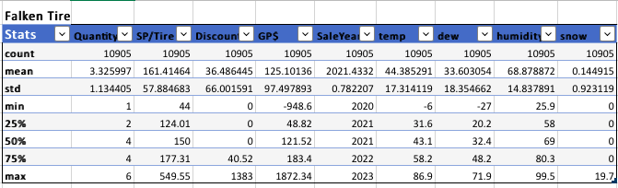

Customers usually buy 3.33 tyres each transaction on average, with a $161.41 average selling price per tyre. Additionally, the data shows an average tyre discount of $36.49, translating into an average gross profit per transaction of $125.0. We can see some significant disparities between these numbers and the Goodyear, Multimile Tyre, Sumitomo Tyre, and Solar Tyre databases. Compared to Goodyear and Solar Tyre, Falken Tyre has a higher average quantity and a lower average selling price. However, compared to Multimile Tyre and Sumitomo Tyre, its average selling price is cheaper. In comparison to Goodyear and Solar Tyre, Falken Tyre also gives a considerably greater average discount, whilst Multimile Tyre and Sumitomo Tyre offer a smaller average discount.

**Vanderbilt tire**

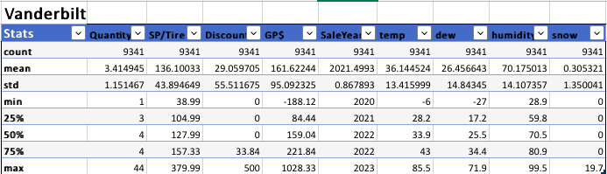

Customers often buy 3.41 tyres each transaction on average, with a $136.10 average selling price per tyre. The analysis also shows an average tyre discount of $29.06, translating into an average gross profit of $161.62 per transaction. These figures show some significant differences when compared to the Goodyear, Multimile Tyre, Sumitomo Tyre, Solar Tyre, and Falken Tyre datasets. Compared to all other tyre brands, Vanderbilt Tyre has a greater average quantity. Its average selling price is greater than Sumitomo and Solar tyres, but lower than Goodyear, Multimile, and Falken tyres. In comparison to Falken Tyre, Vanderbilt Tyre offers an average discount that is higher than that of Goodyear, Multimile Tyre, Sumitomo Tyre, and Solar Tyre.

**Goodrich tire**

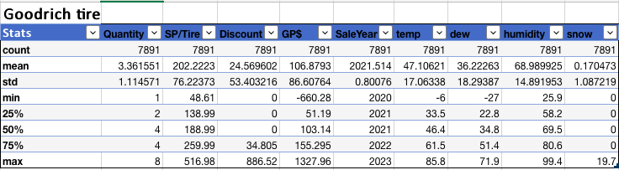

On average, customers purchase approximately 3.36 tires per transaction, with an average selling price per tire of $202.22. The dataset also indicates an average discount of $24.57 per tire, resulting in an average gross profit per transaction of $106.88. Comparing these statistics with the Goodyear, Multimile Tire, Sumitomo Tire, Solar Tire, Falken Tire, and Vanderbilt Tire datasets, we can observe some interesting patterns. Goodrich Tire has a relatively higher average selling price per tire compared to all the other tire brands. However, its average quantity and discount are comparable to the other brands.

**Correlation Plot**

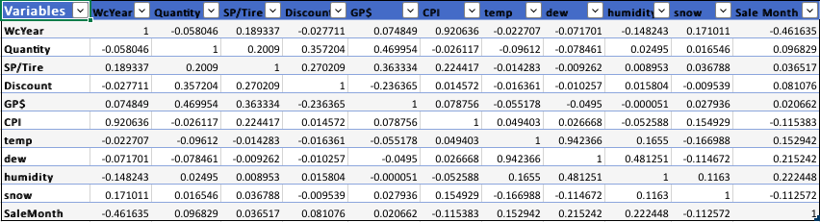

Looking at the correlation plot, we can observe the following patterns:

* WcYear (Week Year) has a positive correlation with CPI (Consumer Price Index), indicating that as the years progress, there is a tendency for the CPI to increase.
* Quantity has a positive correlation with SP/Tire (Selling Price per Tire) and GP$ (Gross Profit), suggesting that higher quantities sold are associated with higher selling prices and gross profits.
* Discount has a positive correlation with Quantity, indicating that higher discounts are associated with higher quantities sold.
* GP$ (Gross Profit) has a positive correlation with Quantity, indicating that higher quantities sold are associated with higher gross profits.
* There is a positive correlation between WcYear and snow, suggesting a tendency for snowfall to increase over the years.
* SaleMonth has a negative correlation with WcYear, indicating a decreasing trend in sales volume as the months progress within a year.

**Now going forward with our Analysis, we will target the locations where the VIP tire stores are available.**

**We have categorised those stores into four locations:**

* **MA - Massachusetts**
* ME - Maine
* NH - New Hampshire
* VT – Vermont

Let's take Maine and New Hampshire first into consideration

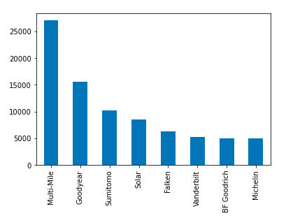

**Maine**

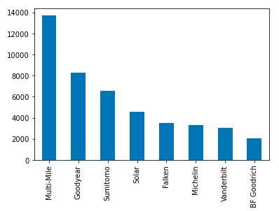

New Hampshire

We can clearly see for both Maine and New Hampshire, multi-miles are sold almost twice as Goodyear, then comes Sumitomo and Michelin comes last. This could be due to price differences and discounts, as discussed in descriptive stats.

Now let us examine Massachusetts and Vermont

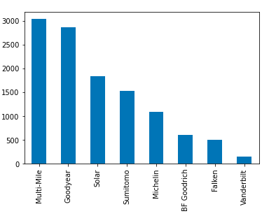

Massachusetts

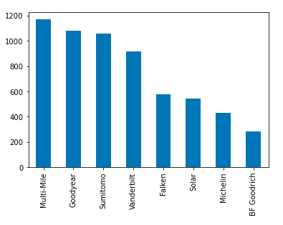

Vermont

For Massachusetts, Goodyear tire sales are very high and solar tires are also high. Also, here Michelin tires are sold more, and Vanderbilt comes last. ¶

This might suggest people are of higher affluence in this state as Goodyear and Michelin tires are priced higher

For Vermont, again goodyear and Sumitomo tire sales are high. Vanderbilt tires are sold most in this state particularly than any other state.

But as these states have lesser sales than Maine and New Hampshire, anything suggested could be substantial.

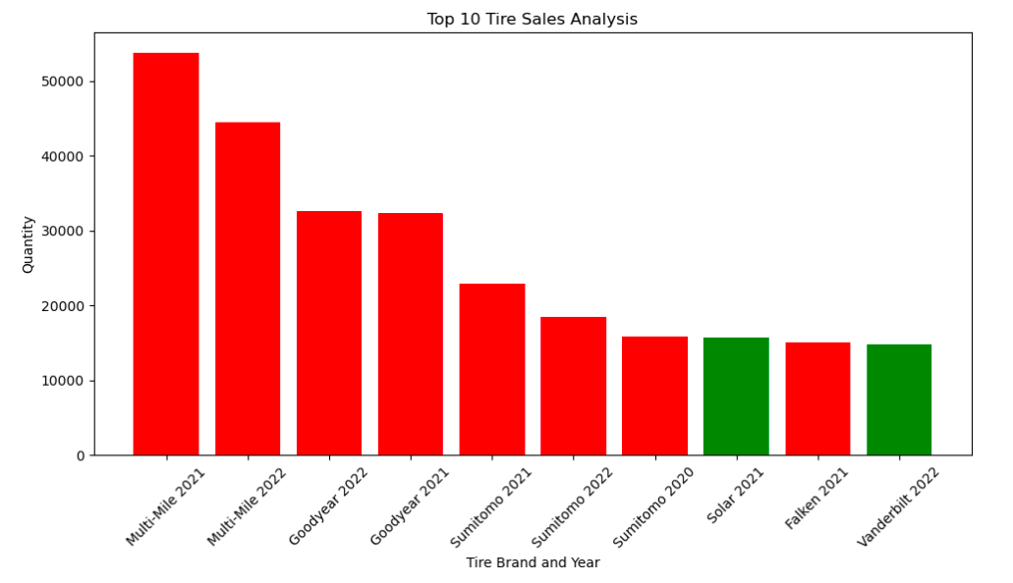

This interprets some of the top selling brands year wise. They already categorised in the primary brands.

Multimile Tires are topping the charts for the consecutive years which shows it’s popularity in the tire market.

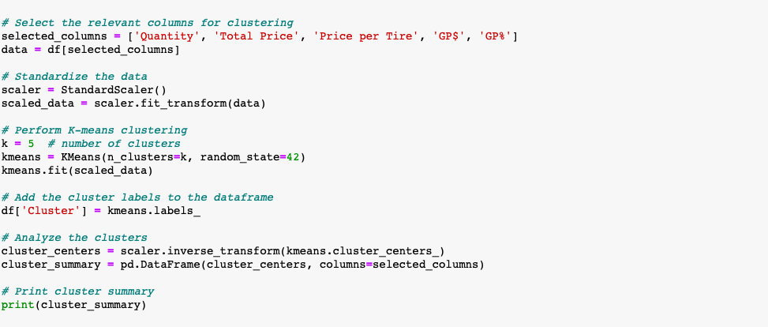

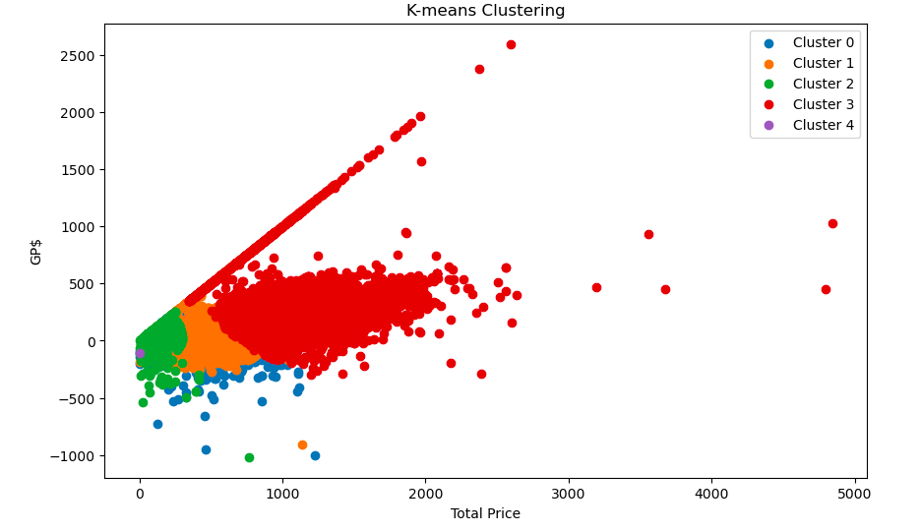

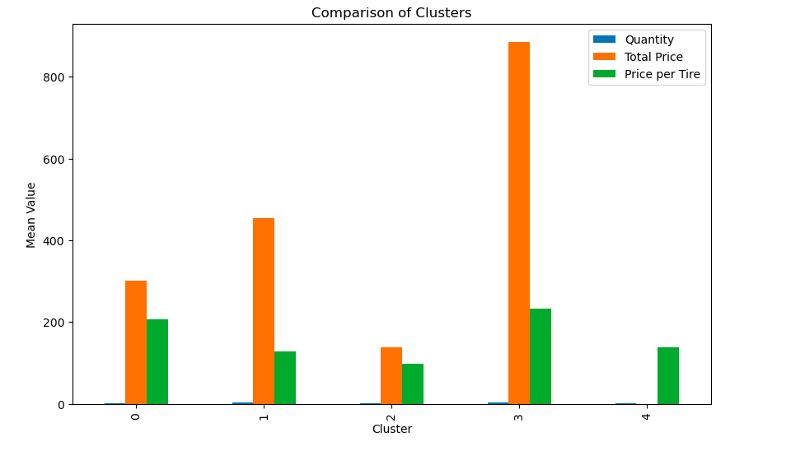

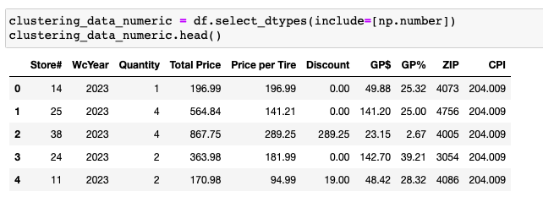

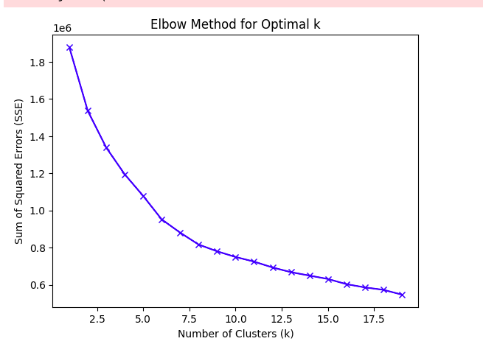

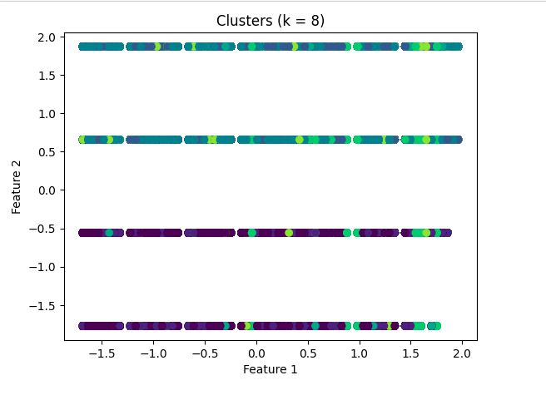

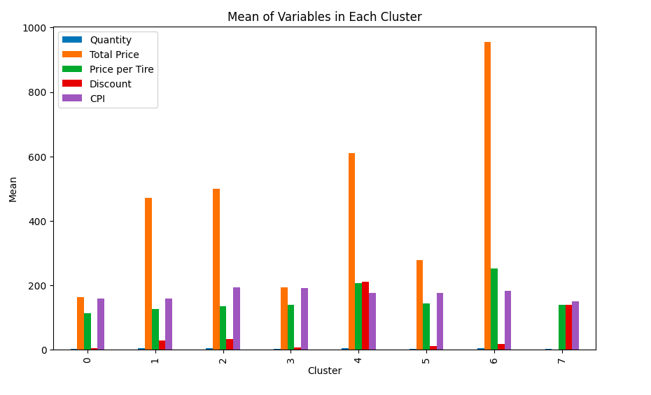

**References**

1. Pedram, A., Nukman, Y., Udoncy, O. E., Mahat, A. B., Pedram, P., & Babalola, A. (2017, February 1). Integrated forward and reverse supply chain: A tire case study. Waste Management. <https://www.sciencedirect.com/science/article/pii/S0956053X16303348>
2. Mahama-Musah, F., Vanhaverbeke, L., & Gillet, A. (2020). The impact of personal, market-and product-relevant factors on patronage behaviour in the automobile tyre replacement market. Journal of Retailing and Consumer Services, 57, 102206. <https://www.sciencedirect.com/science/article/abs/pii/S0969698920301533>
3. Hu, Y., Burris, M. W., & Bhat, C. R. (2021). Examining consumer preferences for tire characteristics: A stated preference approach. Transportation Research Part A: Policy and Practice, 147, 205-224. <https://doi.org/10.1016/j.tra.2021.05.017>
4. Caulfield, J. (2022). What Is an Annotated Bibliography? | Examples & Format. *Scribbr*. <https://www.scribbr.com/citing-sources/annotated-bibliography/>
5. Python, R. (2023). NumPy, SciPy, and pandas: Correlation With Python. *realpython.com*. https://realpython.com/numpy-scipy-pandas-correlation-python/
6. Demo. (2021, October 8). *Consulting Report: How to Write and Present One - SlideModel*. SlideModel. https://slidemodel.com/consulting-report-how-to-write-and-present-one/